**How to order database and create SOA repository with RCU**

**Prerequisite**

1. Please check Database environment running on EXA machine or on SOP environment.
2. After that check NLS_LENGTH_SEMANTICS, If it is char change to Byte. And restart PDB or Database.

SELECT db.parameter AS parameter, db.value AS database_value, s.value AS session_value, i.value AS instance_value FROM nls_database_parameters db LEFT JOIN nls_session_parameters s ON s.parameter = db.parameter LEFT JOIN nls_instance_parameters i ON i.parameter = db.parameter WHERE db.parameter = 'NLS_LENGTH_SEMANTICS';

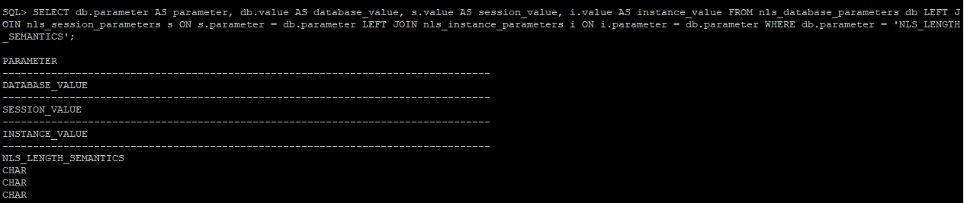

ALTER SYSTEM SET NLS_LENGTH_SEMANTICS=BYTE scope=both;

Restart Database or PDB

**A If the Database is in EXA (Exadata) these are the guidelines**

1 Login to machine **ap-njgorcu1d.oneadr.net**

On a shell window execute command

***2 pushd /u01/ninjainst/run_rcu/EXA/reference_install***

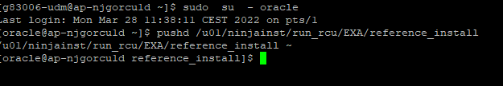

3 Run script ***./do_ref.sh* DB-Host DB-Port DB-service SYS-password**

the input parameters should be in that exact order

Example:

**./do_ref.sh ora-njsobs.oneadr.net 1521 njsobs SYSPassword**

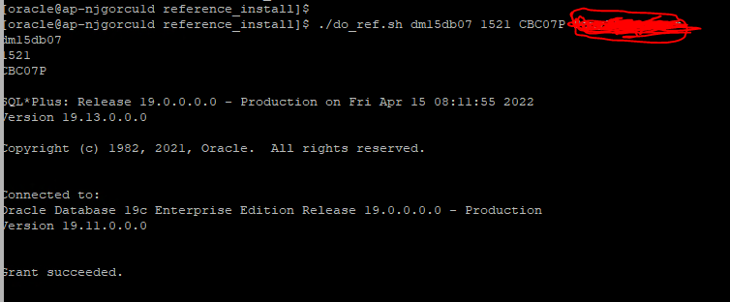

**If the Database is in SOP (Standard Oracle Platform) these are the guidelines**

1. On a shell window execute command:

2. ***pushd /u01/ninjainst/run_rcu/SOP/reference_install***

3 Run script ***./do_ref.sh* DB-Host DB-Port DB-service SYS-password**

the input parameters should be in that exact order

Example:

**./do_ref.sh ora-njsobs.oneadr.net 1521 njsobs SYSPassword**

**ALL component status should be success**

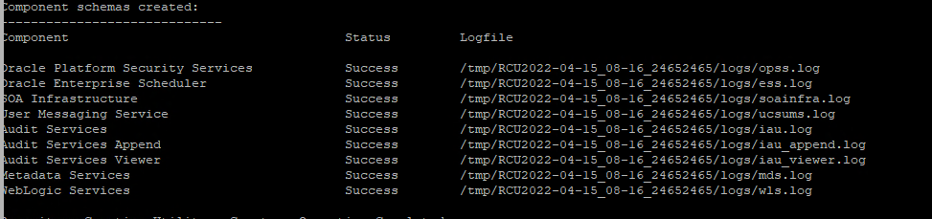

**Run Repository Creation Utility - *This step is executed for each new Ninjago Instance***

**If the Database is in EXA (Exadata) these are the guidelines**

1. Login to machine **ap-njgorcu1d.oneadr.net**

Do this step *if Ninjago instance is using version* ***12.2.1.4***

***B*** Run correct command for product SOA(BPM/BAM), OSB:

For **SOA** or **OSB** run command ***pushd* /u01/ninjainst/run_rcu/EXA/122140/soa_osb**

If database is **DEV / TEST / PREPROD**,

then run script ***rcu_run_soa.sh* DB-Host DB-Port DB-service SYS-password PREFIX PREFIX-Password**

The input parameters should be in that exact order

**Note: Prefix should be mentioned in Task**

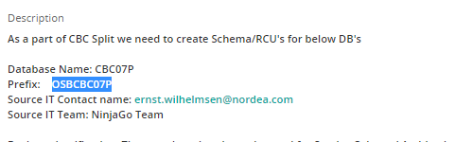

Example: **./rcu_run_soa.sh ora-njsobs.oneadr.net 1521 njsobs SYSPassword SMESOA01 Zaq1Xsw2Cde3Vfr**

**The PREFIX-password should be a generated password 16 CHAR long with upper-case, lower-case and numbers.**

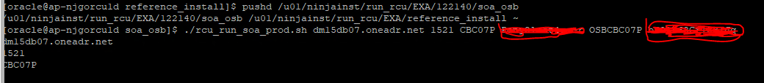

If database is **PROD**,

then instead run script ***rcu_run_soa_prod.sh* DB-Host DB-Port DB-service SYS-password PREFIX PREFIX-Password**

The input parameters should be in that exact order

Example: **./rcu_run_soa_prod.sh ora-njsobs.oneadr.net 1521 njsobs SYSPassword SMESOA01 Zaq1Xsw2Cde3Vfr4**

**POST CHECK**

**All Component status should be in success.**

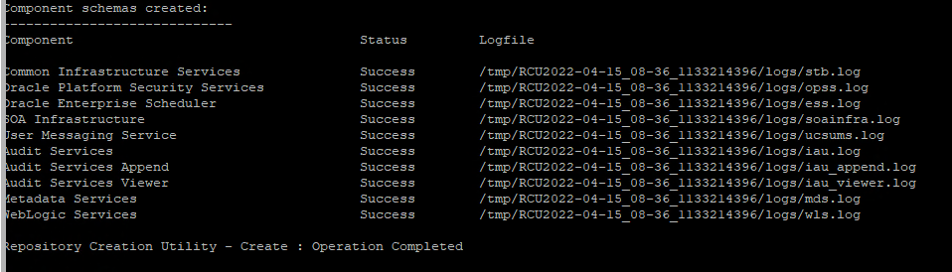

**Run Repository Creation Utility - *This step is executed for each new Ninjago Instance***

**If the Database is in SOP (Standard Oracle Platform) these are the guidelines**

1. Login to machine **ap-njgorcu1d.oneadr.net**
2. Do this step *if Ninjago instance is using version* ***12.2.1.4***

Run correct command for product SOA(BPM/BAM), OSB:

For **SOA** or **OSB** run command ***pushd* /u01/ninjainst/run_rcu/SOP/122140/soa_osb**

If database is **DEV / TEST / PREPROD**,

1. then run script ***./rcu_run_soa.sh* DB-Host DB-Port DB-service SYS-password PREFIX PREFIX-Password**

**Note: Prefix should be mentioned in Task**



Example:

**./rcu_run_soa.sh ora-njsobs.oneadr.net 1521 njsobs SYSPassword SMESOA01 Zaq1Xsw2Cde3Vfr4**

If database is **PROD**,

Then instead run script

***./rcu_run_soa_prod.sh* DB-Host DB-Port DB-service SYS-password PREFIX PREFIX-Password**

The input parameters should be in that exact order

Example:

**./rcu_run_soa_prod.sh ora-njsobs.oneadr.net 1521 njsobs SYSPassword SMESOA01 Zaq1Xsw2Cde3Vfr4**